- \Operation\Tube filling\Lifter\Tube filling – lifter – timing
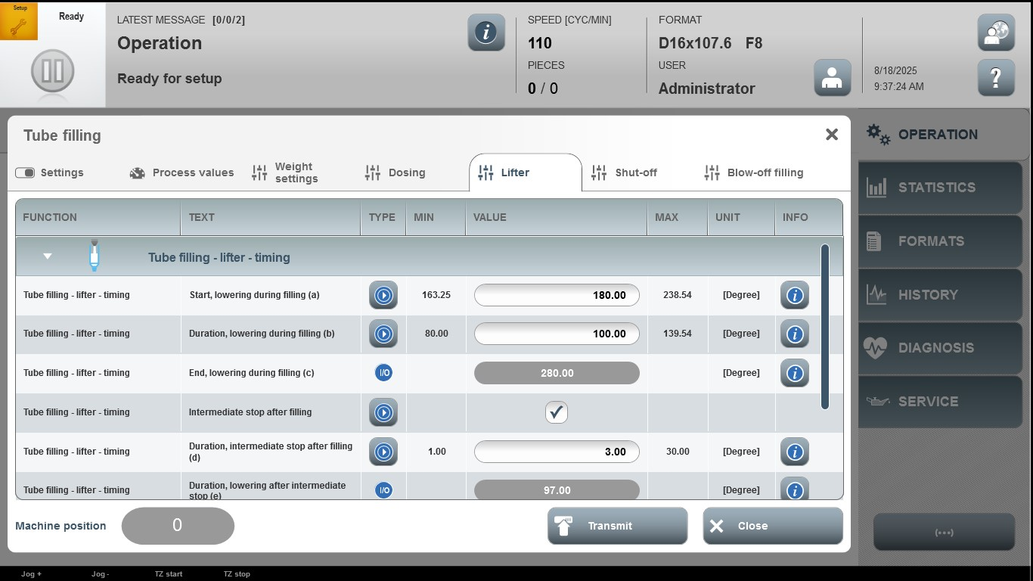

Acceptance criterion | Limits | Pass / Fail: Dev-No. | Date | Initials
Screen matches screenshot | N / A
Start, lowering during filling (a) | 163.25…238.54
Duration, lowering during filling (b) | 80.00…139.54
Duration, intermediate stop after filling (d) | 1.00…30.00

